Game Development

IT6034 Project

Endless

**Game Design Document**

Name: Vitor Cazella

Student ID: 91050051

# Game Details

## **Name**

Endless

## Team

Design, Production and Coding: Vitor Antunes Cazella

## Date of last update

23 September 2020

# Characters and Assets

|  |  |
| --- | --- |
| **Sketch** | **Used** **asset** |
| Spaceship |  |
| Shoot |  |

**Level’s background**

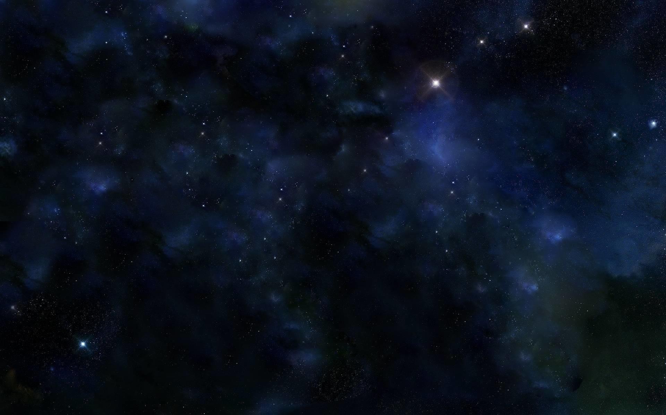 

**Asteroids and others**



# Game Flow Summary

Start screen

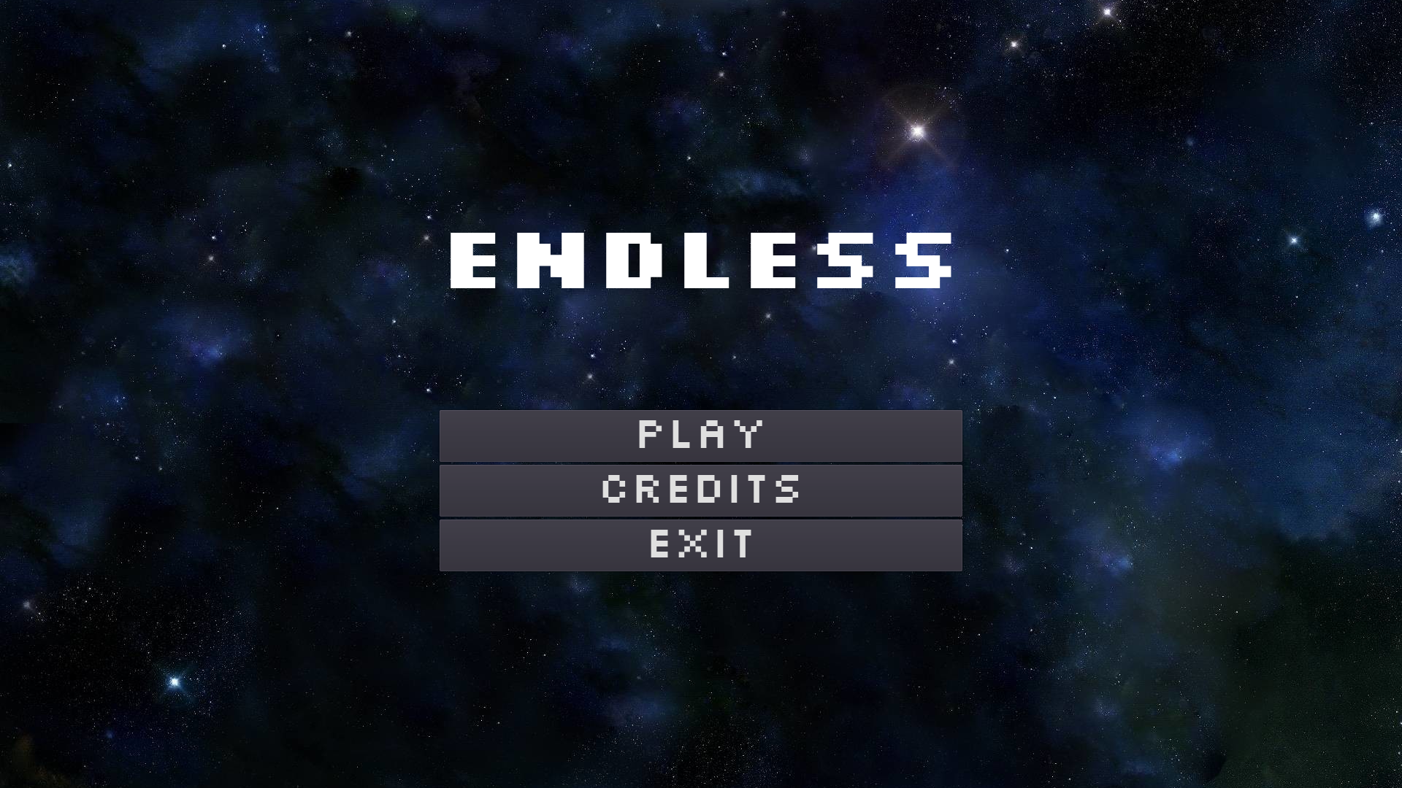

Level 1

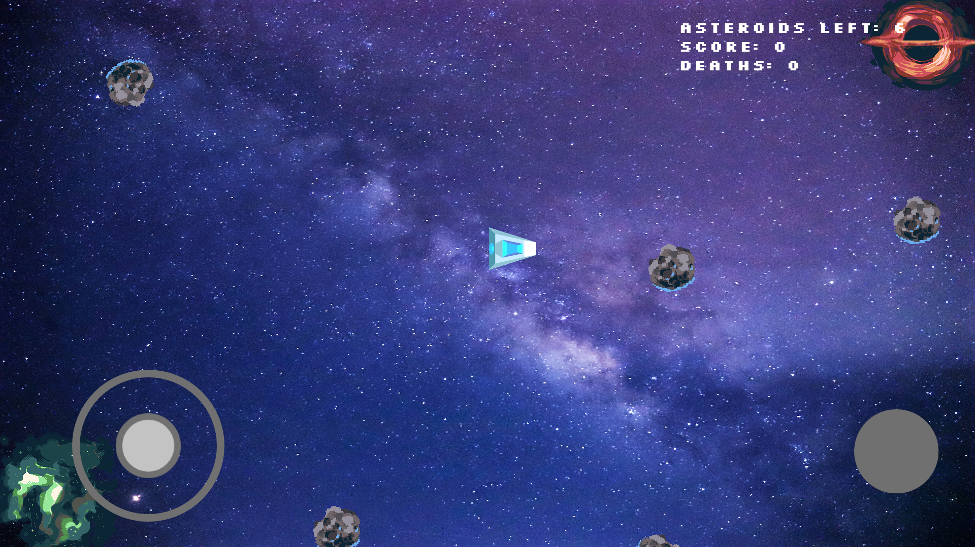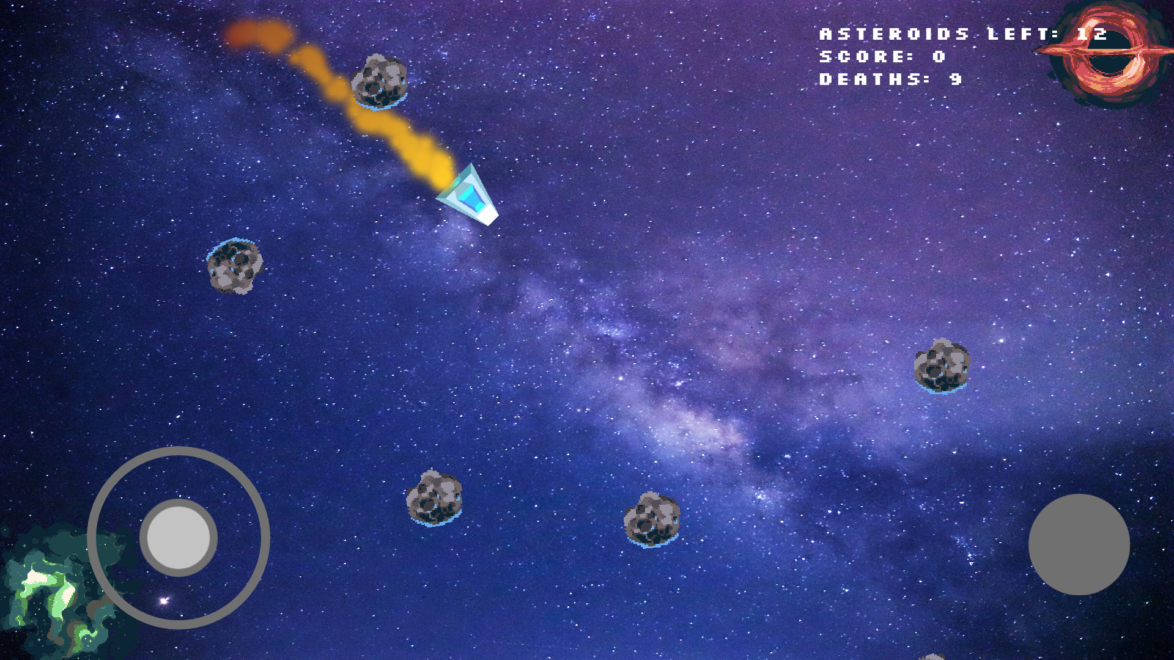

Level 2

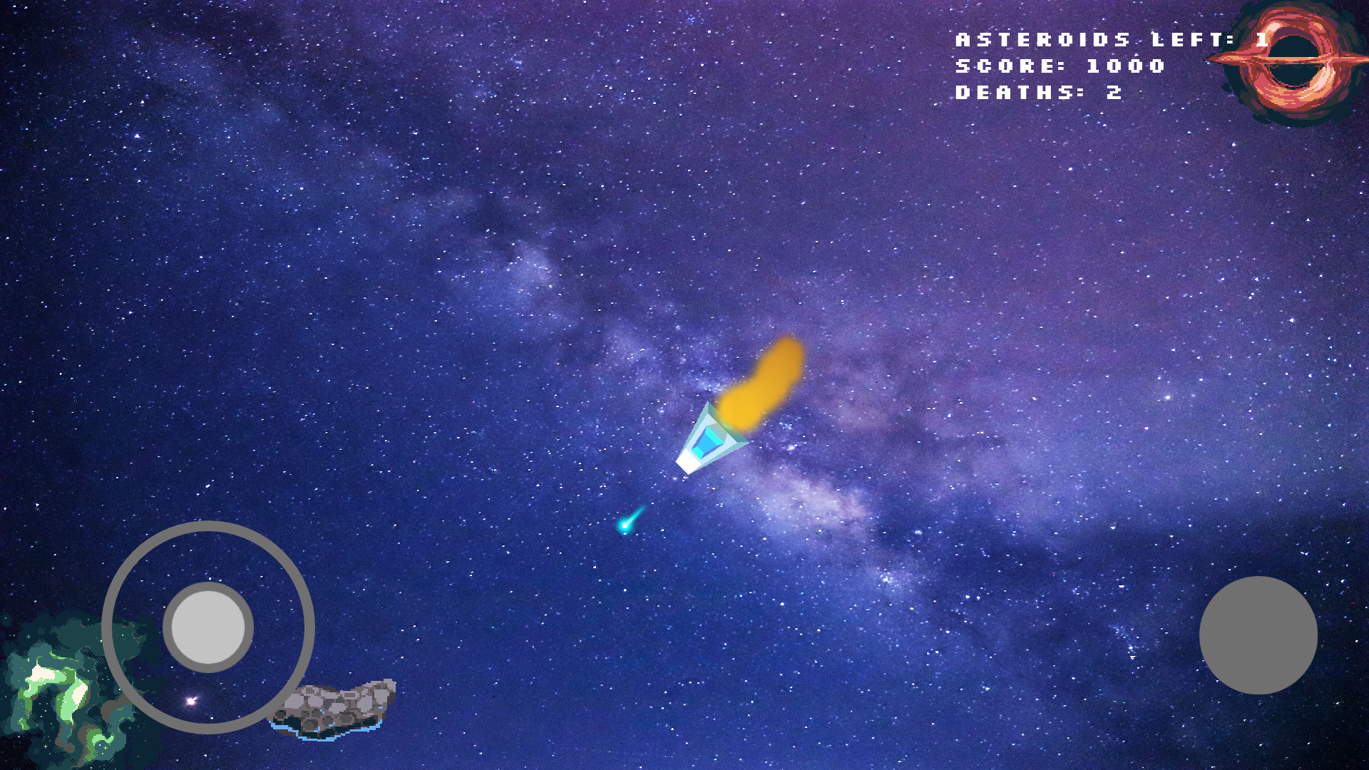

Game Over screen

